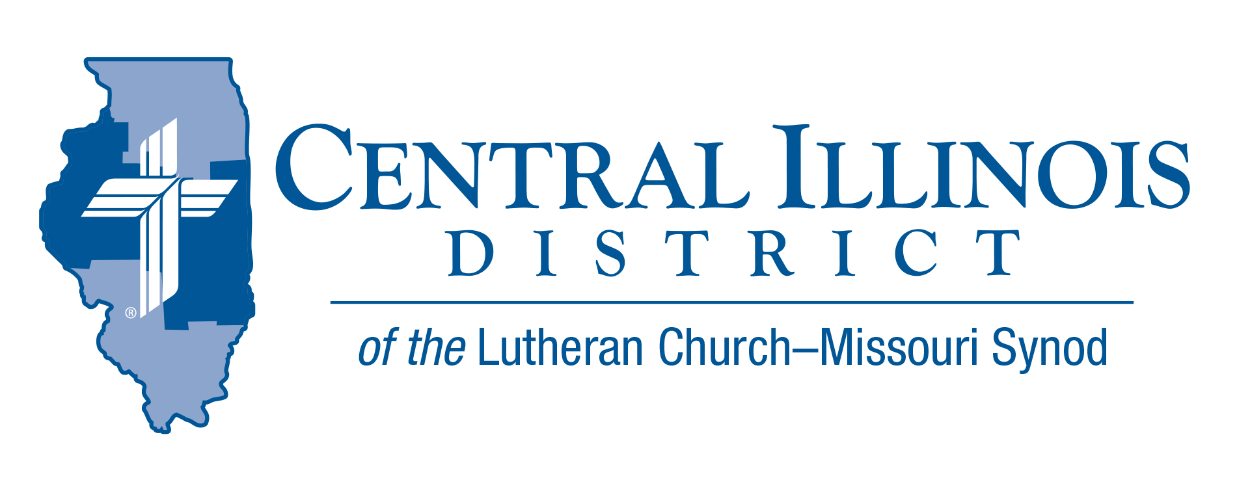
October 2020
News that You Can Use

DEVOTIONS / Invitation to Pray

Change of the Season
Fall is here, leaves are changing, average temperatures are dropping. On November 1, another change is that we set our clocks back one-hour (Fall Back). With this we “gain” another hour (of which we lose as we change all the clocks in our houses). The evenings’ darkness comes earlier, sometimes as we are heading home. This is also the time to change out our summer clothes to fall/winter clothes. We also make sure that we have our cars ready for winter with all the proper equipment. But this has not been a normal season with COVID 19.
In 2 Timothy 4:2 it states, “…preach the Word: be ready in the season and out of the season: reprove, rebuke, and exhort, with complete patience and teaching.” No matter what season of the year, we are to have the Word of God preached and taught. Most of the time we come together to hear His Word in congregations with worship services and Bible studies. But during this current time the church has had to develop other ways to provide the all-important gifts of God. Congregations have found new ways to reach into the households of members and nonmembers. We have developed new outreach activities in our communities. During this “season” we still have been able to preach His Word and sacraments even though some of our churches have had attendance restrictions.
As we move forward, our prayer is that God’s Word and sacraments will be heard and used in our daily life. We also pray that we will be able to gather as His people once again, to be together with the communion of saints. But until that time we have the hope in Him, that His Word will provide us with comfort and strength.

Trip Rodgers Central Illinois District Office

Pray For Our Central Illinois District Missions supported by your church’s Mission Dollars to the District. “Finally, brothers, pray for us, that the Word of the Lord may spread rapidly and be honored.”

Please remember in your prayers the Evangelical Lutheran Church of Latvia, a church body to which CID has given many gifts in the past, as she continues to work faithfully in a former communist and atheistic nation, proclaiming that we have a Savior from sin and death: our Lord Jesus Christ.

ITEMS OF INTEREST TO SHARE

Planning a Mission Festival? Find help on the CID website. Our Mission Festival Toolkit offers a suggested sermon, a listing of CID missions and contact information on CID mission speakers, PowerPoint presentations on some CID missions, an archive of Mission Stories, suggestions on funding a Mission Festival, and more. Go online to http://www.cidlcms.org/missionfestivaltoolkit.html

Treasures Old and New: A Virtual Conference on Adult Faith Formation. October 20 – 22, 2020

Pastors and congregational leaders in the Church face new missional challenges in our “post-Christian” context. This free conference* (led by Rhoda Schuler/St. Paul’s and Kent J. Burreson/St. Louis) will introduce participants to a model of adult faith formation and discipleship with roots in the catechumenal practices of the early church. Through presentations and conversations with LCMS pastors who have developed successful adult faith formation, participants will explore new ways to form disciples through catechesis; to shape Christian identity through the biblical narrative and the sacramental life of the church; and to foster a habitus of hospitality in congregational life.

For more information about this conference, its leaders and program, and to register for this conference, go to https://www.forminglutherans.org/

*This program is made possible through a Vital Worship Grant from the Calvin Institute of Christian Worship, Grand Rapids, Michigan, with funds provided by Lilly Endowment Inc.

ACROSS OUR DISTRICT
Meeting 21st Century Religious Challenges is the topic for the 2020 Springfield East and West Circuits Convocation at Immanuel, (2750 E Sangamon Ave) Springfield on October 24th. Registration is at 8:30; presentation starts at 9:00 and ends at noon. Rev.
Dr. Ken Schurb of the CID staff will discuss such things as Atheism and the New Atheism, Postmodernism, and Church Planting. All are welcome!

DID YOU KNOW?
      - Events that have been canceled or postponed can be found on the CID website http://www.cidlcms.org/events-calendar.html
- People have contributed over $6000 to endowment funds for CID Campus ministries in the last six weeks. http://www.cidlcms.org/outreach-missions-campus.html
- Looking for a way to connect with your online visitors- visit our Website http://www.cidlcms.org/outreach-witness-ministry.html
Stay Connected with your District
Looking for additional information visit https://linktr.ee/cidlcms or connect with the following items:
- CID’s GatePost (newsletter)
- Subscribe to the E-GatePost/Bi-Monthly News
- Stay connect with us on Facebook and Instagram

